E:newsletter.bundyorgard@gmail.com M: PO Box 4158, Bundaberg South QLD 4670
E:secretary.bundyorgard@gmail.com Secretary Karyn Ennor 0447360882
WEBSITE https://www.bundaberg-organic-gardener
WHAT’S ON MID JULY 2020
Hello All,
This has been a busy month with some interesting workshops. Members and visitors who attended, enjoyed meeting with others and sharing a whole lot of new ideas. This is a great way of sustaining us all through uncertain times and keep us all growing in health and knowledge. The more you know the more you grow. The more you grow the more others can see what is possible to share.
There are 2 workshops this month in July. One garden visit to Lenzie’s on the 19th July, and one to Jacques on 25th July on recycling pallets for garden furniture. See below for details.
There is also an important announcement.
Stay Well,
Karyn Ennor (secretary)

Tuesday 28 July we are planning to be back to our monthly meeting at the Uniting Church Hall. Currently we are learning how to arrange the meeting and meet Covid requirements. This is not definite yet but we hope to meet this deadline. The meeting format will be different. Possibly no supper or tea & coffee. Hopefully we can have seedlings to bring and share and lucky door table and selling table and watch this space.
Look for an email about the 25 July and check out Facebook and the BOGI website for an updated confirmation of the meeting – or the old fashioned way, phone a friend.

Teaming with Microbes Discussion continued
by Jeff Lowenfels & Wayne Lewis
In the last newsletter we learnt of the diverse soil life present in healthy soils. Also we acknowledged how modern farming and gardening practices of the last 60 to 80 years have destroyed this vibrant soil life and reduced soil carbon levels. Now we look at ways to renew our soils.
In order to restore soil health and fertility we need to reintroduce soil biology and add carbon to the soil to feed and house the soil biology. The three methods available are to add compost, mulch and compost teas
Composts may add a diverse range of soil biology and is a good carbon source. Compost is good for recycling wastes and may provide a range of nutrients. However, hauling large quantities of compost around your garden or farm is labour intensive and may incur large costs. The discussion follows methods to mix some manures, green waste and some dry materials. Heating is encouraged by anaerobic conditions and then turning and a cooling period.
Mulches of plant wastes are placed on top of the soil to reduce evaporation, prevent weeds and insulate plants. This layer is then slowly incorporated into the soil by insects and worms as it very slowly decomposes.
Compost teas put the soil biology back in the soil quickly. Mulches and composts require large quantities of material and lots of energy and cost to apply. Actively aerated compost teas (AACT) are easy to apply to soil and leaf surfaces and are fast to apply and inexpensive. AACT is not compost leachate or a manure tea which are generally anaerobic. Compost teas use a small quantity of compost as the starter in the brewer and then materials such as seaweed, molasses and fish emulsion are added to encourage a good balance of bacteria and fungi under aerated conditions.
The chapter on Mycorrhizal fungi, the good fungi that grow in and just outside roots, indicates these are not supplied by composts or mulches (or teas made from these sources) and consequently these need to be purchased when shrubs and trees are being grown.
This book is an excellent resource on this subject.
In the next newsletter we will discuss recent research in composts and simple practical ways of making and using compost teas.
Trevor

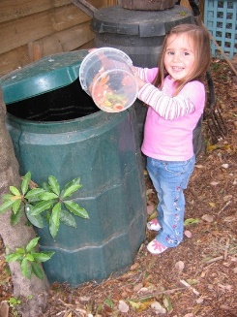

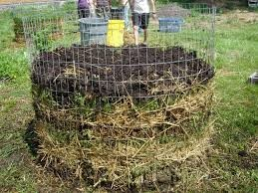

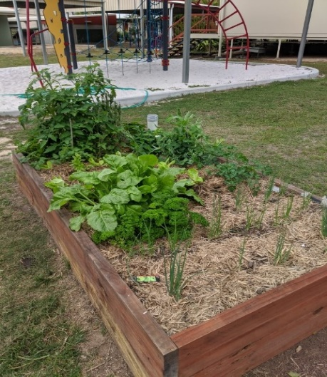

Mt Perry School now has a wicking bed growing vegies much to the delight of the students and their teacher!!

.

Having trouble with your SEEDLING MIX ???
Use a JUNCTION MIX
A Junction Mix is found under a heap of old mulch or compost on the ground. Dig down and at the junction of the soil and compost or mulch remove a layer 1 – 2 cm thick. This will be half soil and half mulch or compost. PURRFECT.
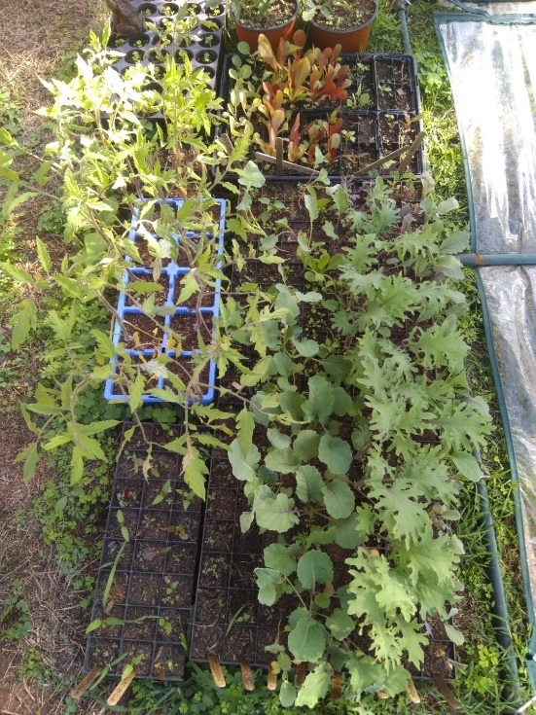
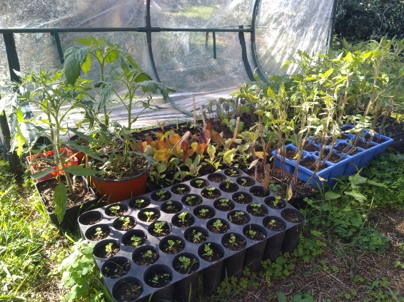
The vigorous activity of soil microbes and insects in this junction will be forming new soil and it is ideal for raising seedlings. Yes, a mix, rich in carbon and nutrients made available by the bugs. Feel it and learn what a good mix feels like!! It will easily absorb water and stay moist.
These seedlings are the result of JUNCTION MIX changing utter frustration into victory !!

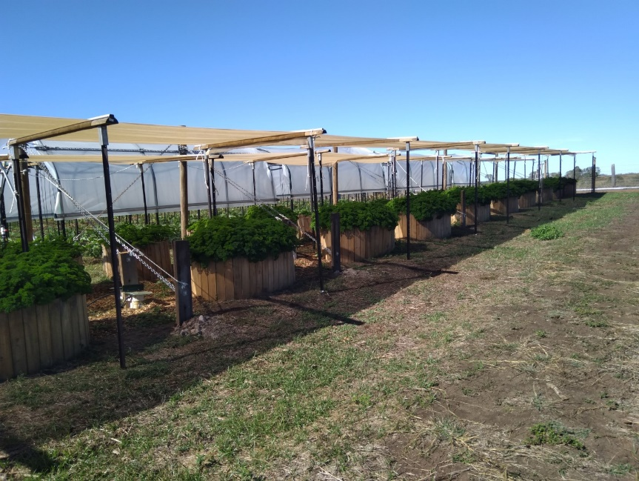
Malcolm & Marlene workshop Sunday 5 July Review
Twenty members and visitors greeted the cool windy conditions at Malcolm and Marlene’s at St Kilda near Gin Gin. They are developing a number of wicking beds with watering systems linked together and then automating the watering. Progress is good and crops are growing well. Great to see innovative techniques being developed.
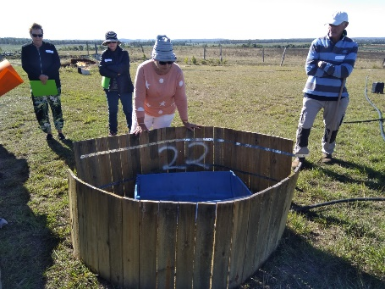
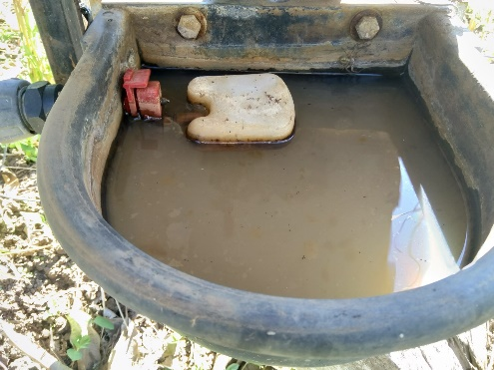
Malcolm & Marlene plan to grow parsley and other herbs for market.

Float on automatic control

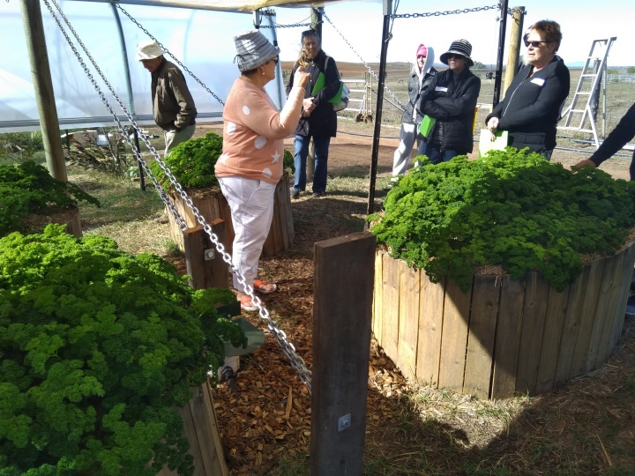
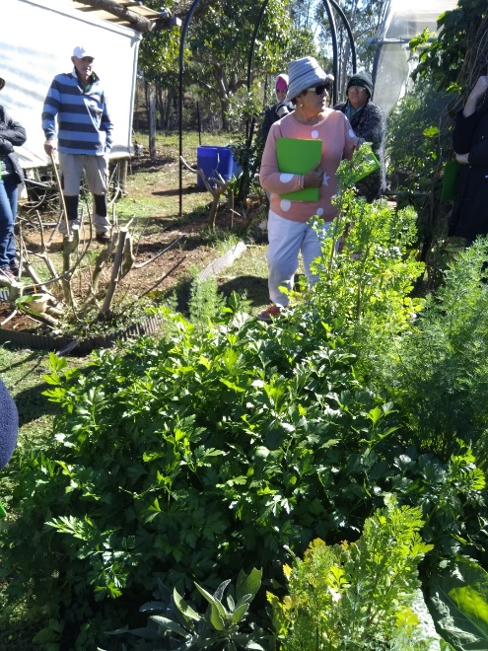

Workshop & Garden Visits
What: | Visit to Lenzie Duffys Garden - as of 15 July spaces available – register now!!
When: | Sunday 19 July from 10 – 12.
Where: | Avenell Heights
BYO: | Lunch, Lenzie will provide hot water & cups

Lenzie has dispensed with grass and now has many exotic fruit trees in the back and vegetables in the front yard. BYO lunch to follow to discuss the mornings information.. Field Trip Limit: 10 People (This will be repeated later in the year )

 | How to Build Pallet Benches with Dave Jacq - also as of 15 July spaces available – register now
When: | Saturday 25 July 10 to 2
 | Avenell Heights
Cost: | $5
Recycled pallets will be used to construct a bench ready for lunch. Dave also makes many other recycled creations from pallets and other materials.
Lunch is a sausage BBQ. Please bring a salad and cover your own specific dietary needs.
Workshop Limit: 6 People

For workshop and garden visits contact the secretary or Trevor 0417196315

