

E: newsletter.bundyorgard@gmail.com M: PO Box 4158, Bundaberg South QLD 4670

E: secretary.bundyorgard@gmail.com Secretary Karyn Ennor 0447 360 882

Website: <https://www.bundaberg-organic-gardeners.com/>

Newsletter July 2020

**Hello out there! After waiting ever so patiently, our club has been given the go – ahead to recommence our monthly meetings starting next week - Tuesday 28 July!**

We are returning to our regular monthly meeting on the last Tuesday of the month. It will be good to see many happy faces. We will need to follow a few extra rules to ensure social distancing. The table arrangement will be different and you will be shown to your allocated seat. Unfortunately, we will not be having food at supper time. Only tea and coffee will be served from the kitchen.

Please bring seedlings to share and an item for the lucky door table as normal. For eager sellers of goods, the selling table and BOGI shop will be open. Hopefully we can arrange a speaker to share some information with us.

Additional assistance will be required before and after the meeting to sanitize and arrange tables etc.

As a welcome back to all members and visitors, our meeting fee will be waived

**Annual membership fees** – as the AGM was postponed in March many of us have not paid our annual fees. Please check if you have paid.

**Annual General Meeting** – now scheduled for the meeting on 25 August. All positions will be vacant and nominations are called for all positions. Please confirm your nomination if you nominated for the postponed March AGM.

**And of course – if you are feeling unwell please stay home, rest up, make some soup with your organically homegrown vegetables and get back to us when you are feeling better.**

What’s in Season?

Who has been lucky enough to receive some ‘rain’ at home in these last few days? It’s just enough to dampen the topsoil but very much appreciated. The end of July will see us coming out of the coldest part of the year and we can look forward to spring planting. Spring always comes early in Bundaberg (just ask the postie being chased by the nesting magpies) and I know we are looking forward to getting some of Lenzies Corn seeds and Sunflower seeds he shared with us at his open day last weekend in the ground and growing.

If someone would like to take over this section of the newsletter please get in touch - Cathy [newsletter.bundyorgard@gmail.com](mailto:newsletter.bundyorgard@gmail.com))

**Teaming with Microbes -- the story continues**

Today we will consider the **SOIL FOOD WEB** – or the ZOO in the soil, or the life in soil.

Healthy soils that support healthy plants generally have many different types of creatures interacting and living in them. One animal depends upon another - to gather food, to gather nutrients, to be eaten, to build carbon food.

One teaspoon of soil may contain billions of invisible bacteria, several meters of fungal strands, several thousand protozoa and a few dozen nematodes.

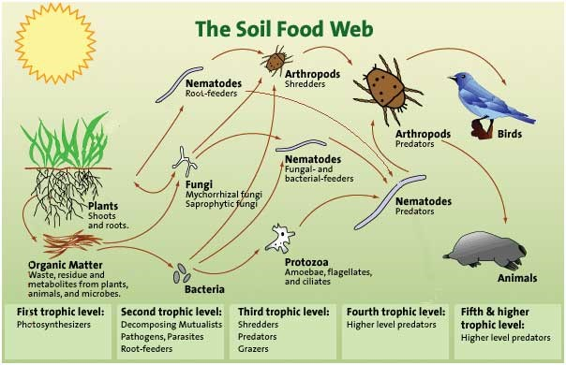 Here’s a summary: The sun provides energy and the plant converts the light to carbon compounds. Some of these carbon compounds are then exuded out of the roots to feed and signal to the soil biology.

After that, simply, each type of organism eats another as the arrows show. The bacteria are eaten by protozoa, nematodes and arthropods. Protozoa are eaten by nematodes etc.

Nutrients are cycled and recycled as one organism eats another.

It is easy to break this important system in healthy soils. Cultivation will increase the rate of breakdown of carbon compounds in the soil. Thereby depleting food reserves. Chemicals and harsh fertilizers may harm one of the soil animals – thus breaking or slowing the soil cycle.

If we adopt practices such as organic growing, permaculture, regenerative agriculture and the like we are building soil carbon (or biology food) reserves and encouraging all groups of animals in the soil food web. The use of compost, mulches and compost teas is also actively encouraging the soil food web. Growing plants is an essential part of improving soil health.

Workshops and Garden Visits

Attending workshops has been a great way to share enthusiasm with other club members while our meetings have been on hold. Please always check booking numbers and notify if you can’t attend on the day. Have you got a secret garden or skill to share with others? Get in touch with our workshop Co-ordinator Pam Burgess at the next meeting if you would like to share it with us.

**What: North Bundaberg Community Garden**

**When:** Saturday 1 August at 8.30 am

**Where:** Gavin St, Bundaberg North (Opposite Oodies Café)

This garden is currently managed by the Hinkler Lions Club. There is a working bee on and we have arranged to attend and participate in this activity. Come along and lend a hand.

**What: Shalom Markets / Sue Jacksons / Tom Quinn Garden Centre**

**When:** Sunday 9 August 9.30 am meet at Sue Jackson's (41514538)

**Where:** Individually visit Shalom Market and see fruit and vegie stalls and probably our members Mathew and Sally selling clean and green produce, then at 9.30 meet at Sue Jacksons house to see her garden and compost bins. Then move to Norville Park for morning tea and walk to Tom Quinn Garden Centre for information and inspection. Contact Joan Smart 0427575650 for further information.

**What:** A Visit to Maryborough Community Garden and also Linda Cameron’s garden just south of Childers

**When: Sunday 13 September**

**Where:** We will arrange car-pooling at the August meeting

Field Trip and Garden visit reports.

**A field trip, a day out in the very peaceful countryside To Malcolm & Marlene Kent's abode**

About 18 members & guests had a bright & sunny field trip recently to the property of Malcolm & Marlene's to see first-hand their commercial use for self-watering, gravity fed, automatic wicking bed systems, that Malcolm created, tweaked & made work, very well. They are currently harvesting in the vicinity of 1000 bunches of parsley per week! Most impressive. Liquid fertilizer can be added into the system as needed. They also are trialling underground versions of it for eggplants.  Marlene is an awesome host, providing scones, jam & cream, salads & kombucha for those who wanted to share lunch. It was crisp but the sun shone, we got out of the wind & had a lovely time.

After lunch some of us headed on to a garden walk with Ray Johnson at the **Gin Gin Landcare gardens**. It’s always a pleasure to visit, Ray is a wealth of good information, the gardens are continually evolving in his loving care & the abundance is everywhere. The trees are all growing well, the rainforest walk is amazing & there are always plants for sale. Thanks to grants, their infrastructure is expanding as well, so I can highly recommend a visit there Wednesdays or Fridays. Cheers from Pam

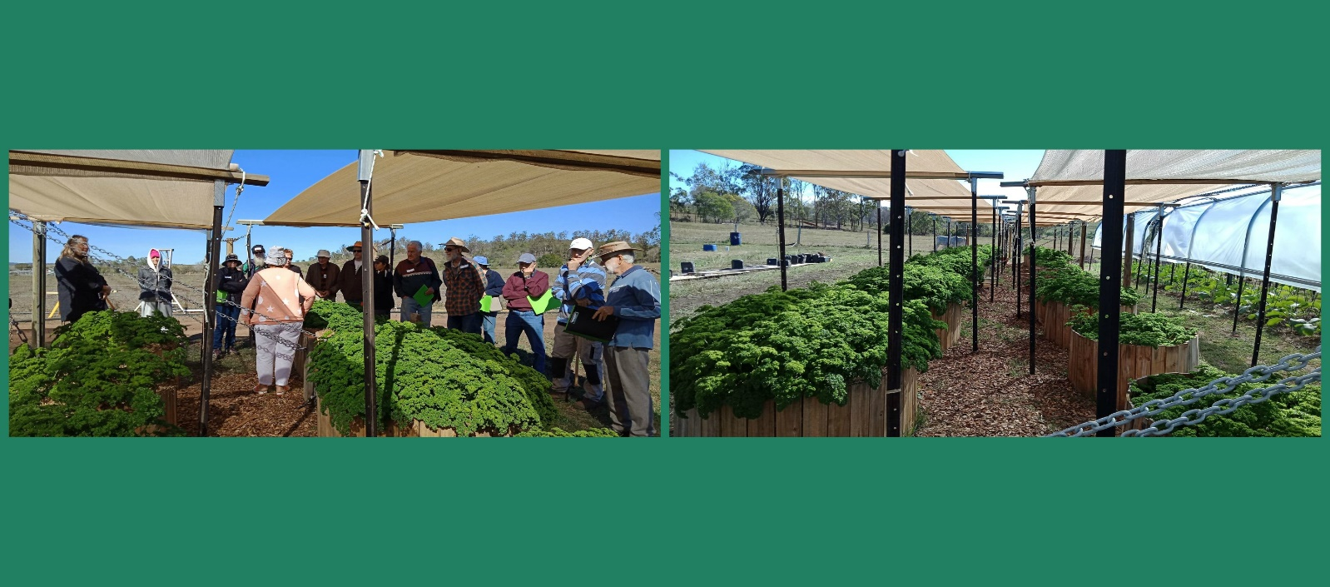

A visit To Lenzie Duffy’s

Last Sunday (19th July) we visited Lenzies amazing ‘little’ suburban garden where he has not wasted an inch on his 869m² block. Lenzie has moved to this property from a large acreage and has not wasted any time in getting the place EXACTLY as he needs it. It was originally a hard ground with not much else but lawn and a soil PH of 4.4. Fast forward 22 months and add 32 ton of compost / soil / mulch and he has completely transformed the place, adding in three large water tanks, which means he has enough water for himself and his garden and not rely on council water. Lenzie hit the ground running and showed us his enormous banana trees (fruiting of course), native bee hives, 3 types of passionfruit vines with enough fruit to feed the suburb, and please correct me if I’m wrong but I think he said over 60 types of fruit trees! Lenzie is a master at grafting and had one tree which was a bush lemon / orange and mandarin all on the one tree. This is what gives him maximum usage of his space. Down the side of his driveway there are many types of fruit trees in Espalier form where he is keeping alive many old varieties of fruit that are not only very valuable to our health but have a historical significance too – true superfoods. Along the other side of the house there were more bananas, passionfruit and dragon fruit and in the front garden we saw flowers covered in bees and many things growing such as Wampie, Jerusalem Artichoke, Coloured Corn, Bernitzky, Sweet Potato, Beans, Soursop, Broccoli, Carrots and Beetroot, also Pyrethrum and Sunflowers.

Many aspects of this visit were inspiring for me – I love upcycling and recycling and was amazed to hear that everything used in the garden was second hand. Discarded shade cloth, old roller doors, car tyres as frame work. Thank you for having us at your place Lenzie – my kids came home with a bag full of Passionfruit, and that was after sitting under the vine eating them for most of the morning. It has to say something when an 8 year old and 4 year old visit an 84 year old and I overhear them saying ‘This place is awesome’ Fun for everyone. Cathy.

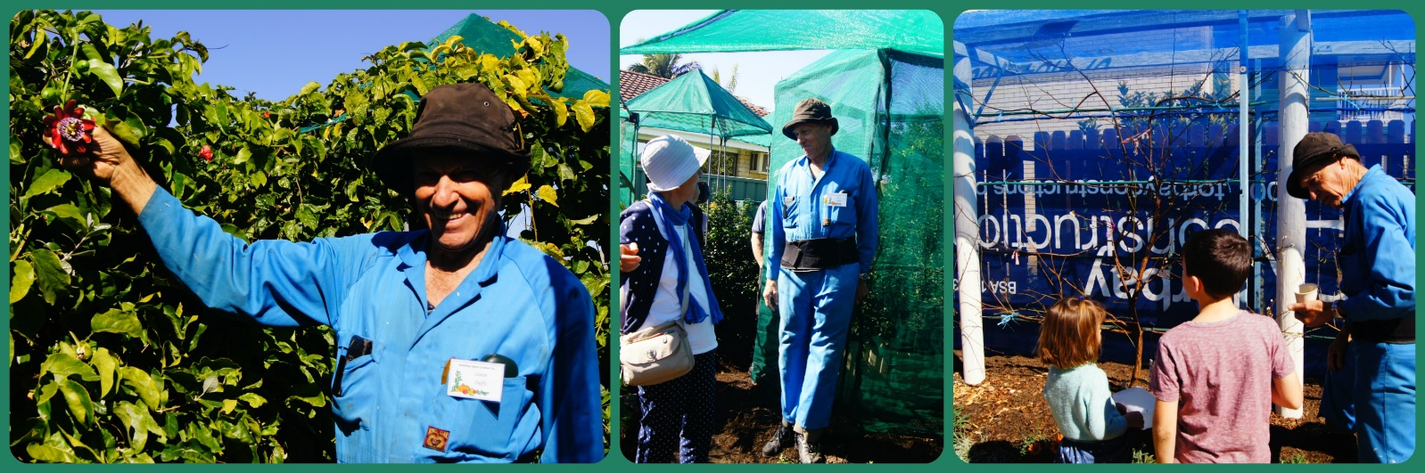

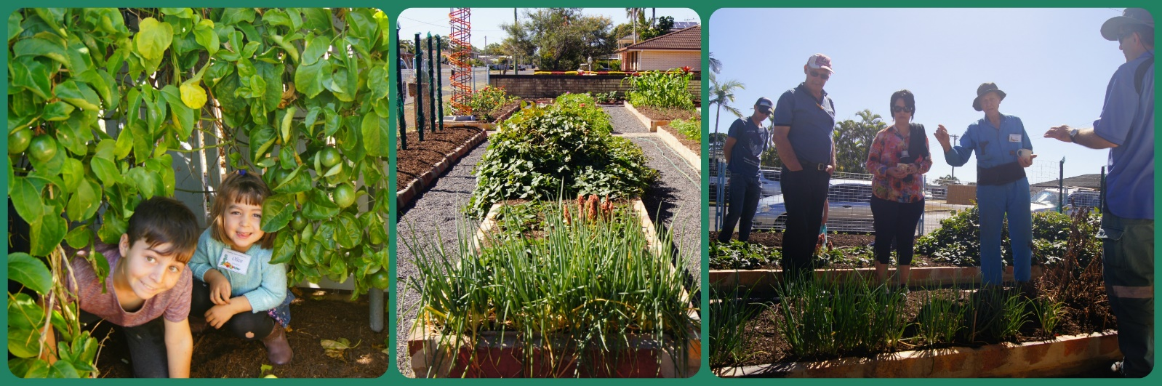

What’s Happening Online!

There have been some great photos and stories shared on our BOGI Facebook page once again, and questions asked and answered where we can. Here we have some photos of ‘success’ from a visitor to our meetings last year – Chris Jensen. *Chris, with what you have been sharing online I think you would be a great addition to our club.*

Follow this link https://www.facebook.com/groups/717598841992819/ or search on Facebook for Bundaberg Organic Gardening Inc

Chris writes “I see in the June newsletter that there are seeds available for the jicama yam. I have been harvesting some over the last few weeks and still have a couple waiting. Easy to grow, I just threw seeds around my garden, and let them go. They make a small vine 3 or so metres, no problems with overgrowing other plants. These are legumes, but only the yam is edible. Everything above ground is potentially toxic, even the pretty blue flowers. If you don't want seeds it is recommended to cut flowers off. Only "problems" I have found is that large ones split in ground, and I need to work at tracking the thin vines to find the tuber. Great eating raw, starchy and sweet, juicy and crunchy. Good dipping pieces into hommus. In my limited experience I would recommend this over yacon, a similar type crop, for ease of growing and eating. Plant when weather is warmer, early spring. Greenharvest website has more info on this plant.”

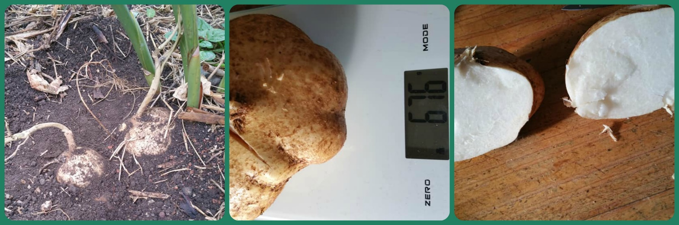

Jicama Growing Information © Frances Michaels  
  
Botanical Name:*Pachyrrhizus erosus*  
Common Names: Jicama (pronounced he'-cama) has a variety of common names including climbing yam bean; Mexican potato; Mexican Water Chestnut; Mexican turnip; cây củ đậu (Vietnam); seng kuang (Malay); di gwa (Chinese); kuzuimo (Japan); sinkamas (Filipino); man kaeo (Thai); sankalu (Hindi).  
Plant Family: Fabaceae  
  
Plant Description  
Jicama is a vigorous, subtropical and tropical, climbing legume vine from South America. It has very pretty, big, blue pea flowers. Sadly, the flowers should usually be removed as the bean pods and seeds are toxic, they also take a lot of vigour from the plant and reduce the harvest of tubers considerably. Let one plant go to seed for your next year's crop.  
Even though this plant is an herbaceous perennial, it is usually grown as an annual, because the root tuber, the perennial part, is also the bit harvested. Jicama can be propagated from a tuber or seed. The plants die back in winter in cool climates but the tubers will shoot again in spring. The root of jicama develops swellings the size of a large turnip, (up to 5 per plant) under the surface of the ground.  
Plant Height: Even though this vine can reach 2 - 6 m tall, it is usually pruned to 1 - 1.5 m as removing the flowers can double the yield of roots. In Mexico it is grown in fields and pruned with a machete.  
  
Sow When  
Jicama is frost tender and requires 9 months frost free for a good harvest of large tubers or to grow it commercially. It is worth growing in cooler areas that have at least 5 months frost free as it will still produce tubers, but they will be smaller.  
Warm Temperate Areas: For areas that have at least 5 months frost free, start seed 8 to 10 weeks before the last spring frost. Bottom heat will be required as jicama needs a warm soil to germinate. Use either the top of a hot water system or a bottom heat propagator. The pots will need to be kept in a warm place. It is unsuitable for areas with a short growing season unless grown in a glasshouse.  
Subtropical Areas: Sow the seed once the soil has warmed up in spring.  
Tropical Areas: Sow all year in the tropics.  
  
Planting Details  
Seed Preparation: Soak the seed in warm water overnight to soften the seed coat and speed germination.  
Planting Depth: Sow seed 5 cm deep.  
Spacing: Space plants 20 - 25 cm apart in rows 60 - 90 cm apart.  
Position: Full sun.  
Soil Type: Jicama prefers a rich, moist, sandy loam soil with good drainage that is high in potassium.  
  
Harvest  
The tubers can be harvested from 4 months for small tubers, it takes 9 months for large tubers to develop. The seed pods and seeds are toxic and dangerous to eat. The pods contain rotenone, a toxic substance often used as an organic insecticide.  
Eating: The sweet, juicy, crisp tubers are eaten raw or lightly cooked. To prepare, peel off the brown skin. The raw tubers taste like a cross between a water chestnut and an apple and do not discolour when cut. It is a great addition to salads and can be used as a crudité. It is also substituted for water chestnuts in stir-fry. In Mexico it is sliced thinly and sprinkled with salt, lemon juice and chilli sauce. As a food, jicama is low in calories, only 45 calories for one cup of cubed root.  
New Crop Potential: As a new crop jicama has potential for small crop growers in warmer areas. We suggest you offer your crop to a local restaurateur, take some prepared pieces and explain how it can be used. Restaurants with a desire to provide fresh ingredients and a willingness to experiment will be at the leading edge of demand for this versatile crop. By selling to the end user you will get a higher value return. Selling at the local produce markets is a sure hit if you always offer free taste samples.  
  
Available as seed: [Jicama - Climbing Yam Bean](https://greenharvest.com.au/SeedOrganic/VegetableSeeds/JicamaToKohlrabi.html#Jicama)

Photos from the haven

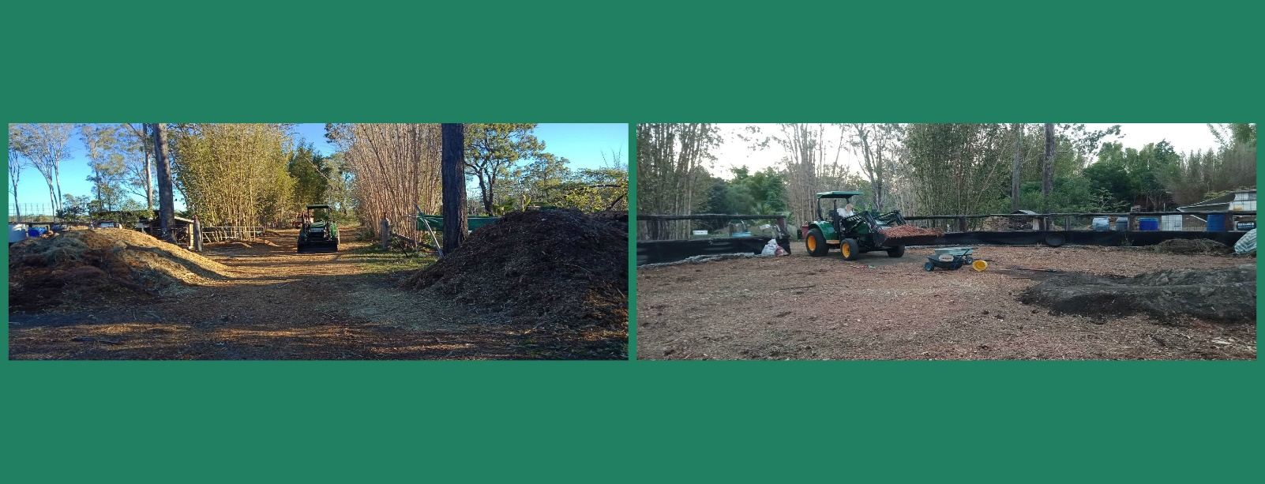

The Haven - an update

Well, with the lack of water (read Rain) in this neck of the woods it was necessary to think outside the square a little. A few phone calls netted us some truckloads of woodchips/tree mulch, a much-needed resource. Our goal is to cover the soil where ever it is bare, sprinkle lightly over soaked oats in the round yard & keep watered to sprout for chicken forage, & heavily mulch fruit trees, sleeping garden beds & bamboos.

Thankfully, Malcolm & Marlene dealt with our overgrown, wayward fruit trees, most of which have had a reshaping prune, so now we have learned another skill, how to get the best from our fruit trees by lovingly pruning at the right time as well as feeding at the right time, something that had escaped me till now. You would not believe the almost overnight change in our lime tree; it is absolutely dripping with flowers. The bees benefit first, then us second.

The insect proof tunnel is going gang busters, with regular liquid manure feeds keeping the greens growing well. We have been enjoying Chinese stir fry, vegetarian spring rolls, Caesar salad & mixed green salads, the recipes just keep on coming. Next week perhaps some Bahn Zeo Vietnamese savoury pancakes. MMmmmmm. I love our garden!!!!

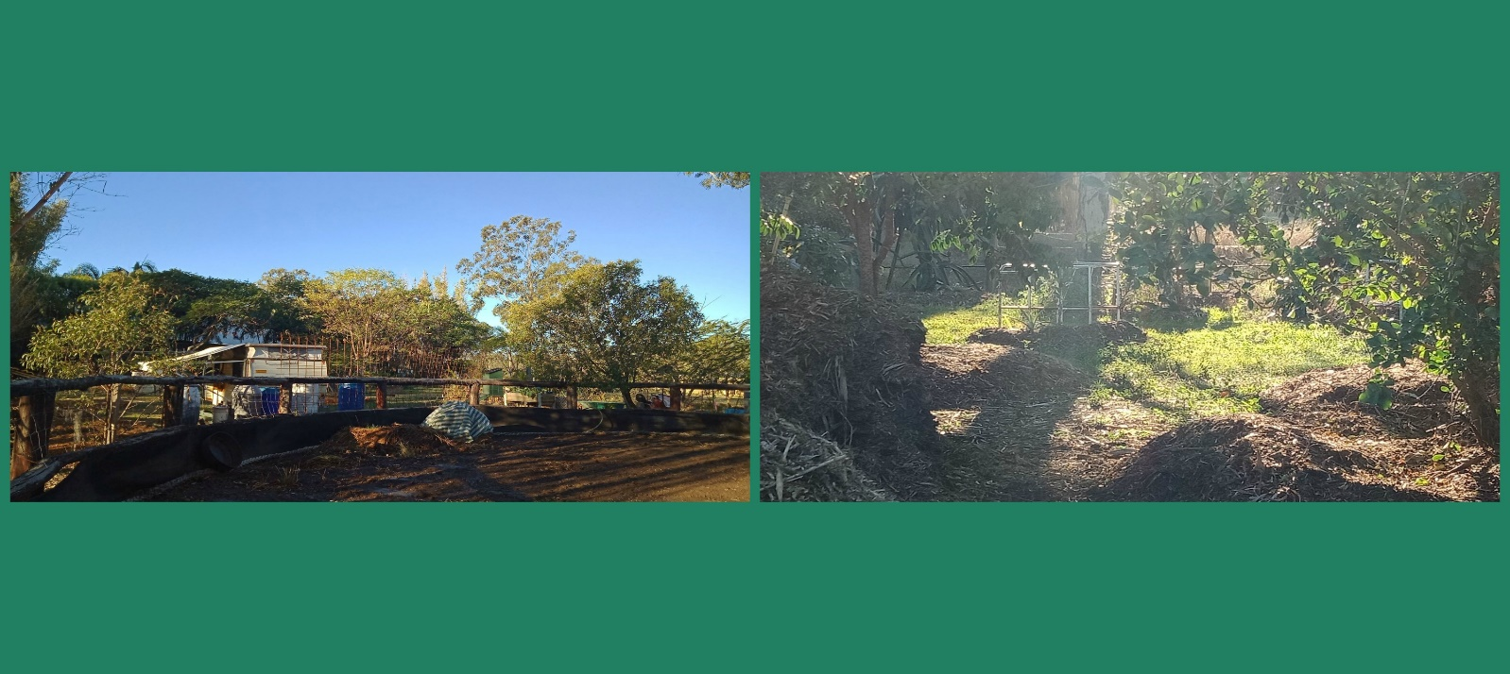

Seed Bank -

Our seed bank currently contains Dill, Loofah, Bok Choy, Black Pumpkin, Cos lettuce, Lucerne or alfalfa, Spinach (tall),Lemon grass, Jicama yam, mini capsicum, large radish, Parsley, Desert Rose, Marigold, Dwarf snake bean, watermelon, Gerbera, Egyptian spinach, Moringa, Desert Rose, pawpaw, rockmelon, jalapeno capsicum.

**Would you like to grow some of these or do you have seeds to add? Then contact Trevor 0417196315**

Handy Information

* Club Members Matthew & Sally Cathcart are selling their produce at Shalom Markets on Sundays.
* Buy organic seeds locally at Woodgate, Claudia and Charlie who have a business

Simply Organic Farming@gmail.com 0407699283.

* **Local honey suppliers**

Bundy Honey, 5 Banks Court, Bargara 0438 882 220 Bundy Honey, 89 Honors Rd, Bundaberg 0409 921 600



**CLUB MEETING**

**Time: Doors open 6.30 pm**

**For a 7 pm start**

**Venue: McNaught Hall**

**(Uniting Church hall**)

Corner **Barolin and Electra Street, Bundaberg**

**Attendance $3-member, $5 visitor, includes supper**

**Attendance Fee waived for July**

**Tuesday 28th July**

**Speaker: Yet to be advised**

As always, we will have the BOGI

~Library ~Shop

~Info sheets ~Buy & Sell

~Seeds ~Tea of the Month

~Lucky Draw ~Photos from workshops ~Freebies ~Workshop registration

***Enjoy a Cuppa at Supper***

**BOGI SHOP**

Products available are:

* Liquid Lime
* Liquid Kelp
* Liquid Fish
* Mineral Granules
* Microlife
* Organibor and
* Katex Organic Super Growth.

They are available for sale at our meetings, but please contact

Bruce McKay on 41544405 for collection from his address in Walkervale.

**Deadline for August Newsletter**

**Please send through information to the editor by the second Friday of each month.**

We would love FEEDBACK from club members on anything and everything.

**Tell us about your success and your failures in the garden and help others learn along the way.**

Let us know about community events or what’s up and coming in the area.

To include notices and details of Club activities email: newsletter.bundyorgard@gmail.com

Or ph Cathy 0403 430 969 or

Heidi 0410 561 314

Please send through articles at any time, if they miss one newsletter, they will make the next.

**This is the official monthly newsletter published by and distributed to the members of Bundaberg Organic Gardeners Inc. Whilst every effort is made to publish accurate information, the Club accepts no responsibility for statements made or opinions expressed, or any consequence arising from them. For further information, contact the Secretary.**